**A FULL STACK DEVELOPMENT CAPSTONE PROJECT**



FoodBox

*(Application Screenshot’s)*

* **Version History:**

|  |  |  |
| --- | --- | --- |
| 1. | **Author Name** | Adan Abdullahi |
| 2. | **Purpose** | Screenshots of Application. |
| 3. | **Date** | 15 August 2022. |
| 4. | **GitHub Details** |  |
| 5. | **Contact** | [*adanabdi254@gmail.com*](mailto:adanabdi254@gmail.com) |

Contents.

* 1. Project Outputs 3

***1.Project Outputs.***



A. Home Page.

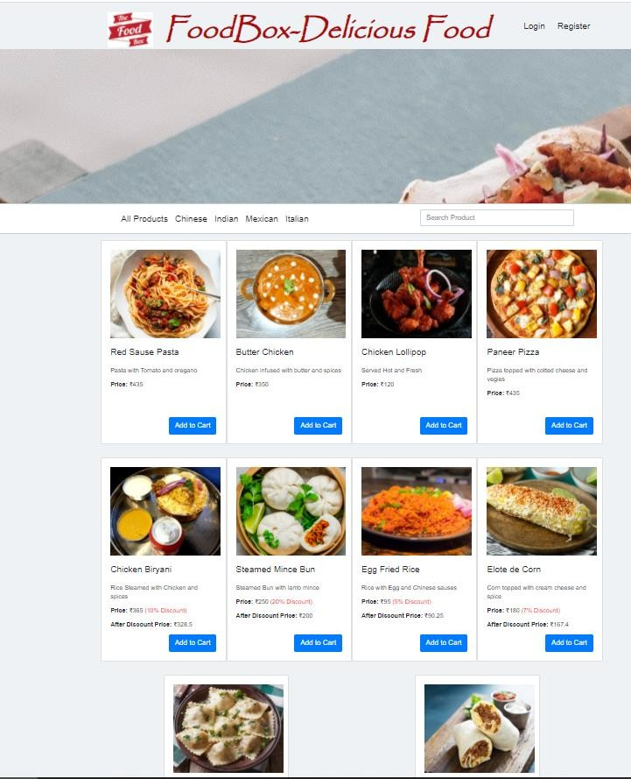



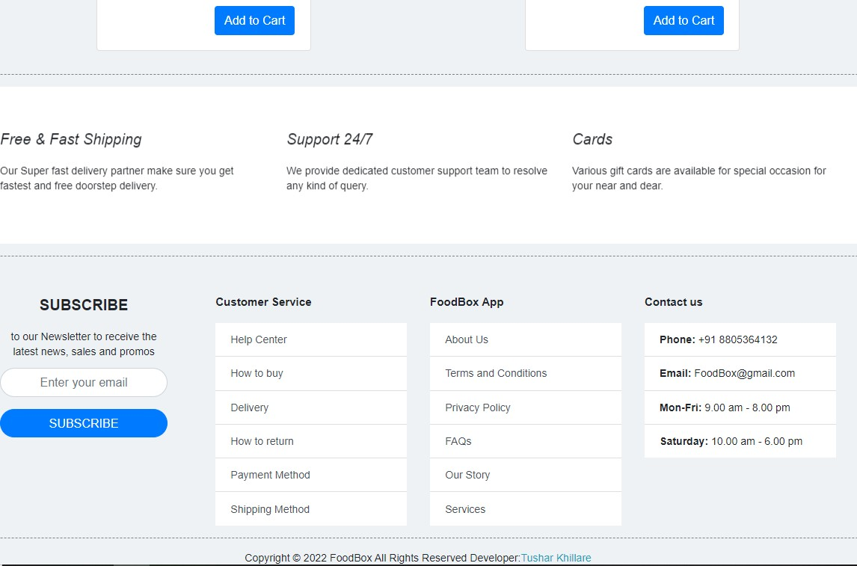





B. Login and Registration Page.

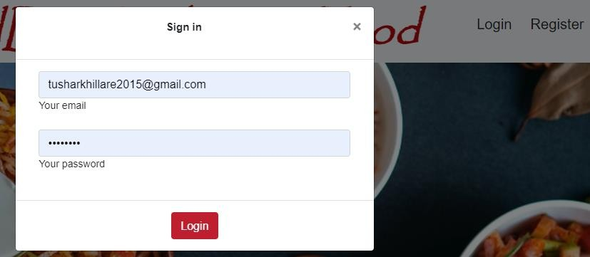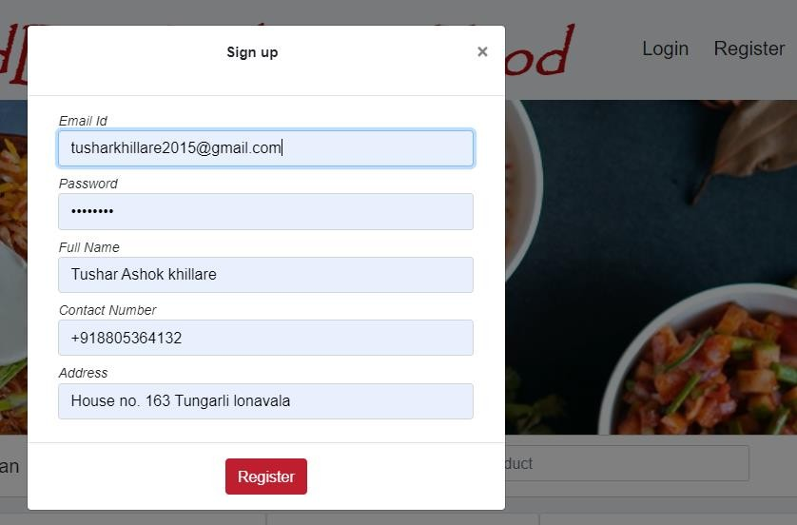





C. Admin Login Page.

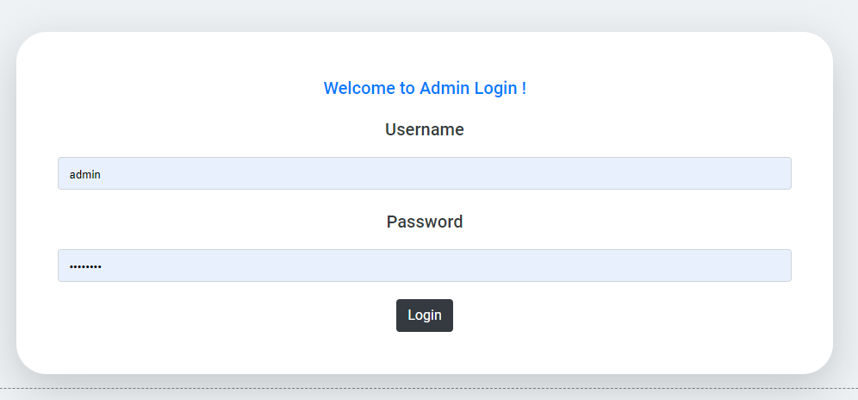

D. Manage Users , Products , Purchases.

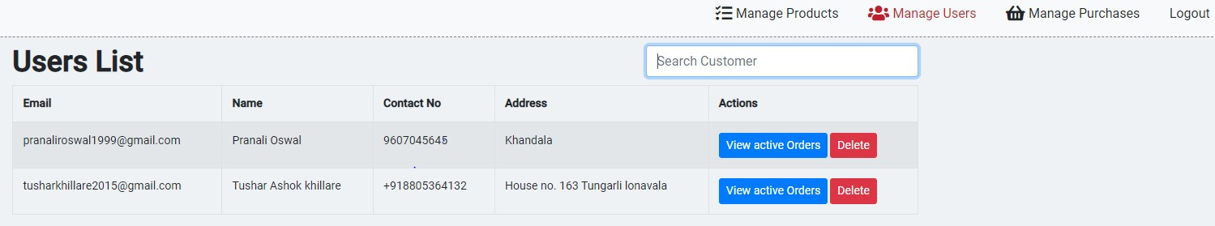

Searching and Sorting:

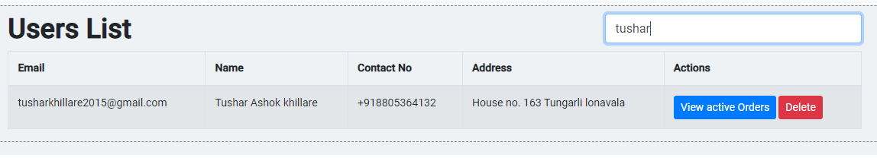

Manage Products:

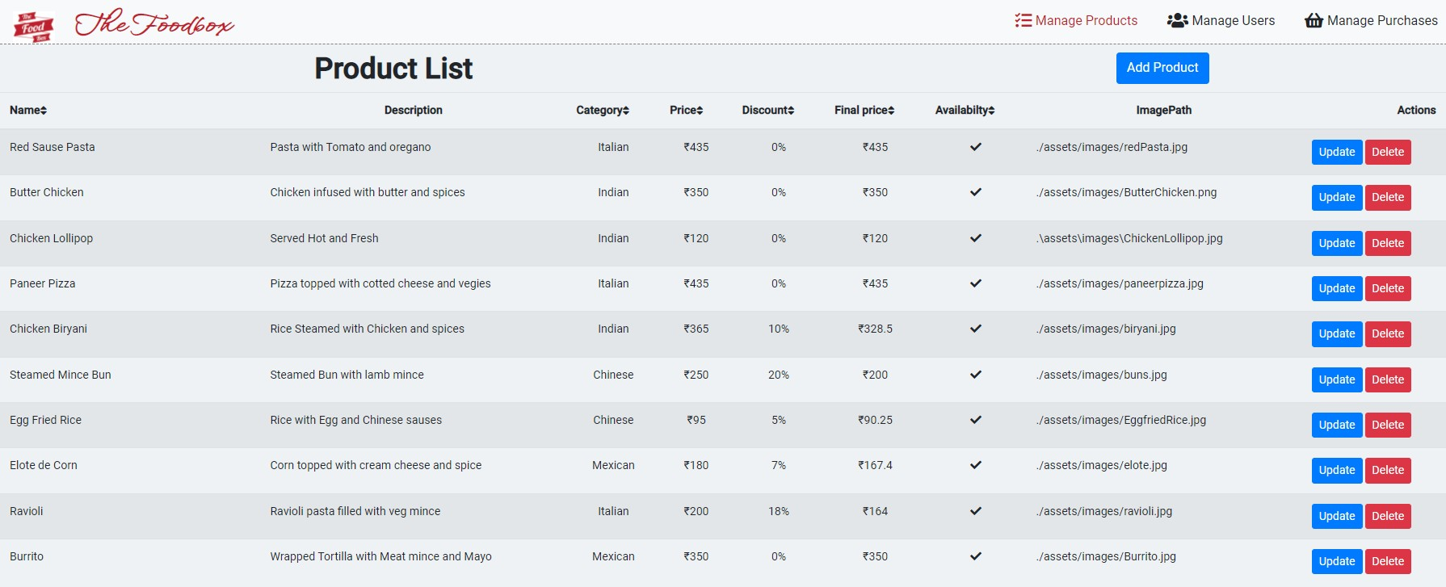

Add Product:

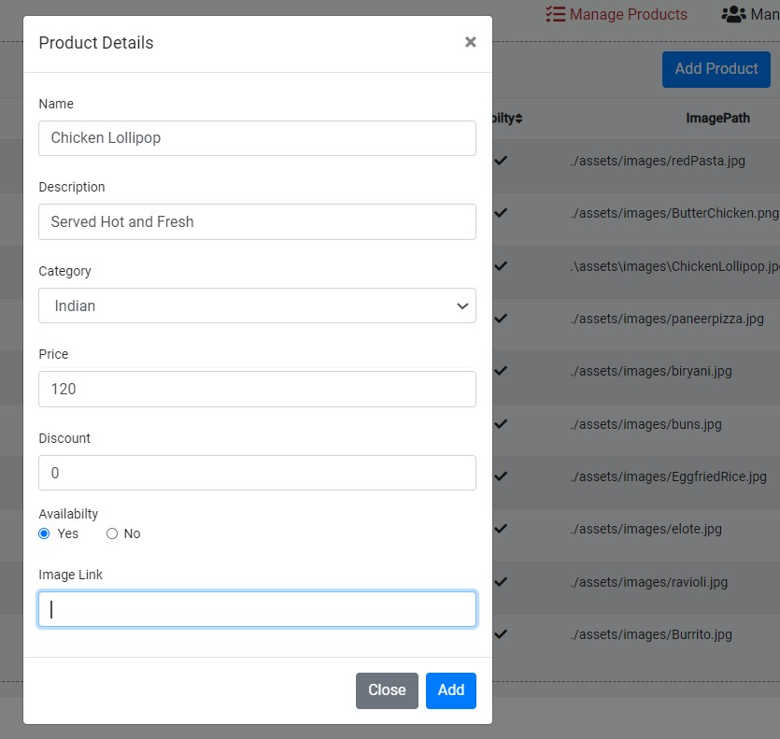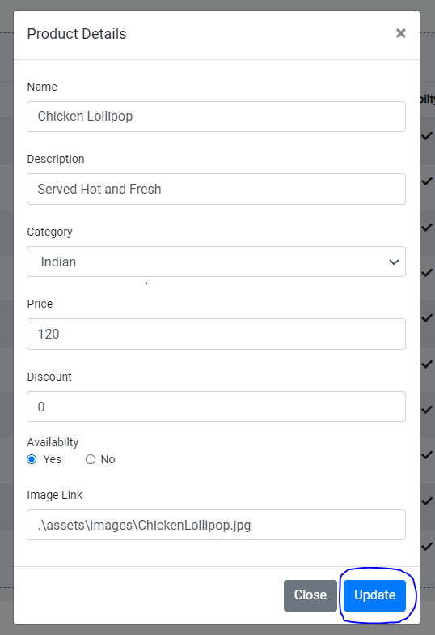

Update Product:

Delete Product:

Product deleted successfully…..

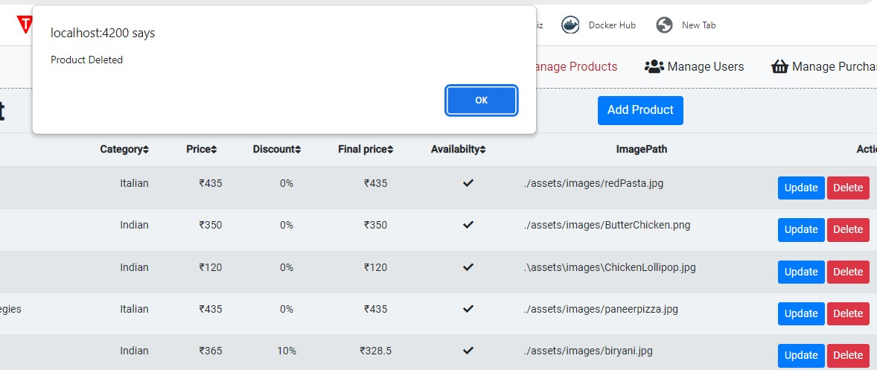

Manage Purchases:

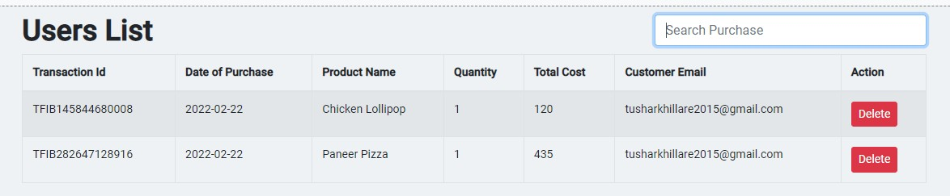





E. View Previous Active Orders.

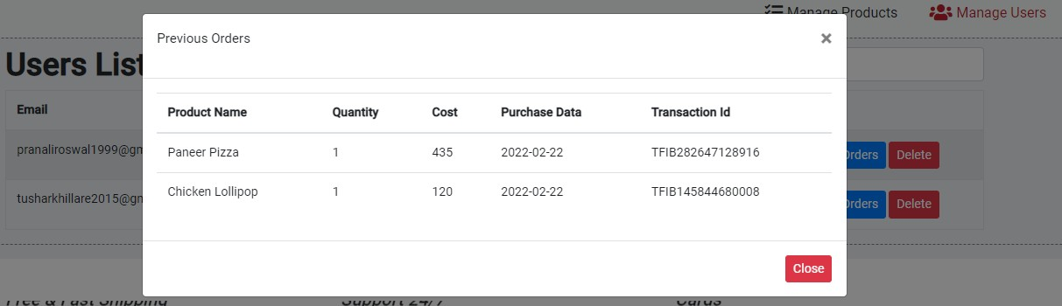

F. User Login.

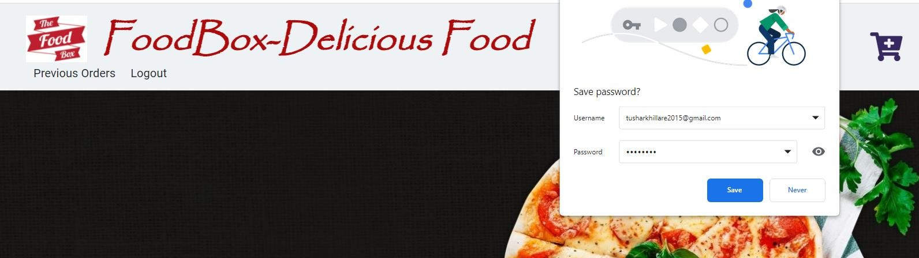

G. Add Cart / View Cart.

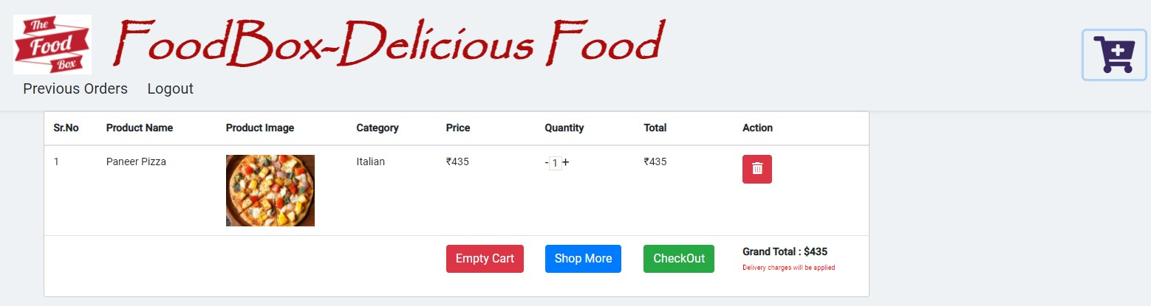

My Cart:

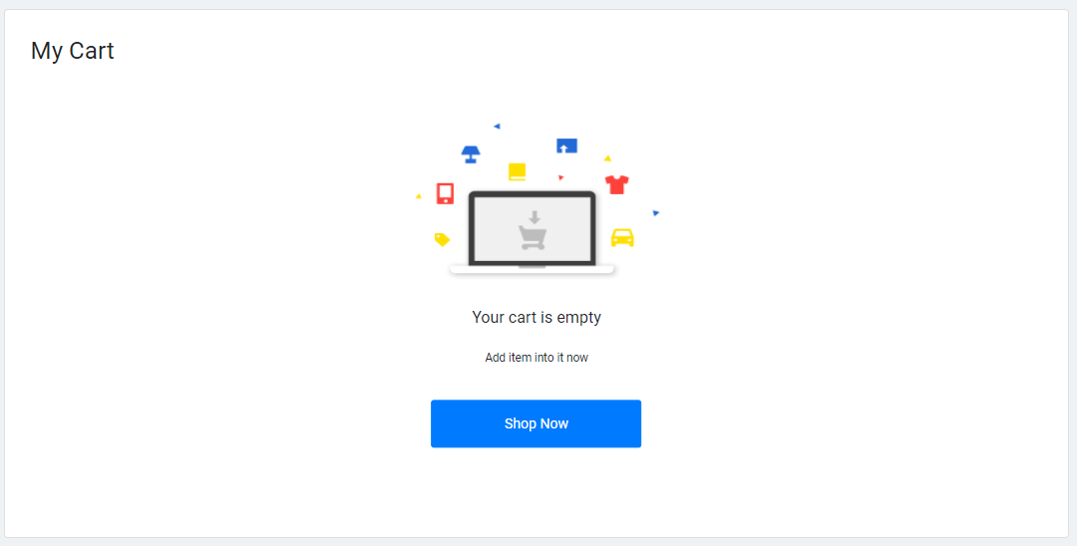

H. Payment Gateway Page.

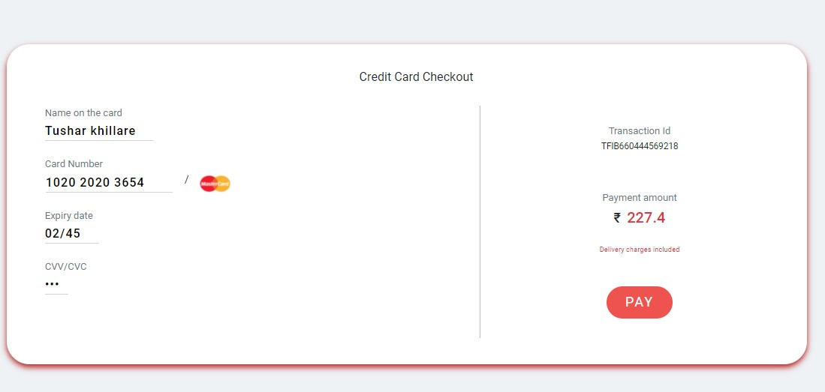

Payment Status:



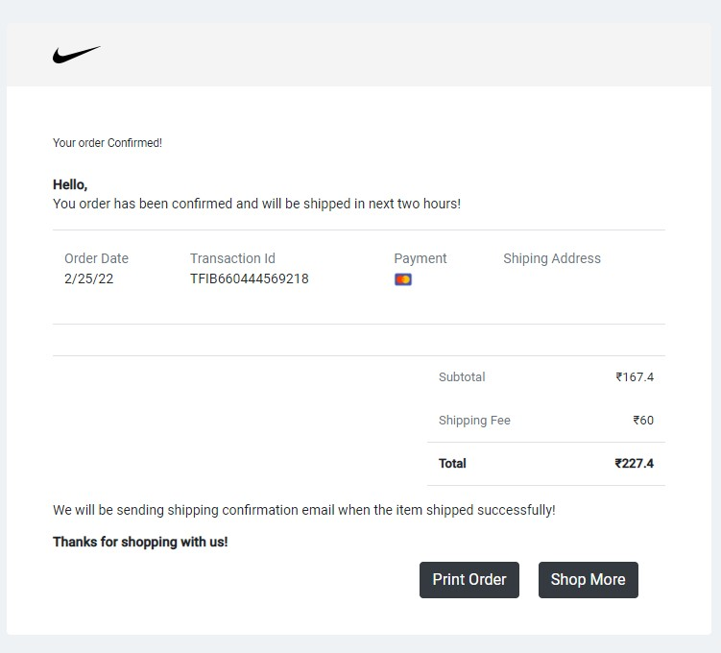

**TESTING AND DEVOPS USING JENKINS**

*Jenkins Build triggered successfully:*

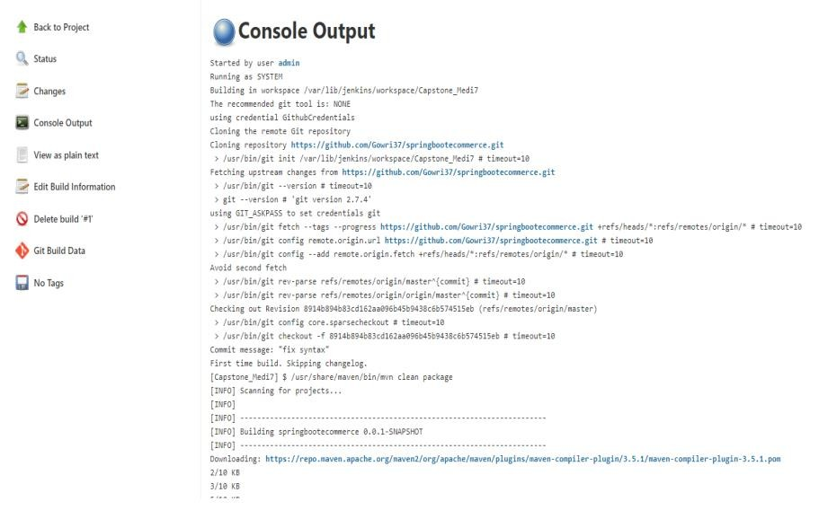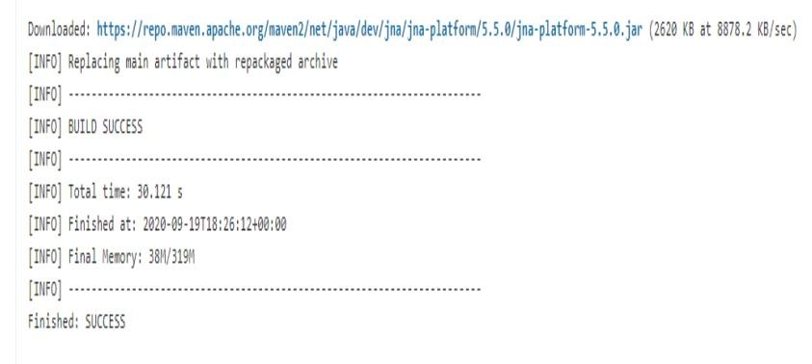

**PROJECT SCREENS POST TESTING AND JENKINS DEPLOYMENT**:

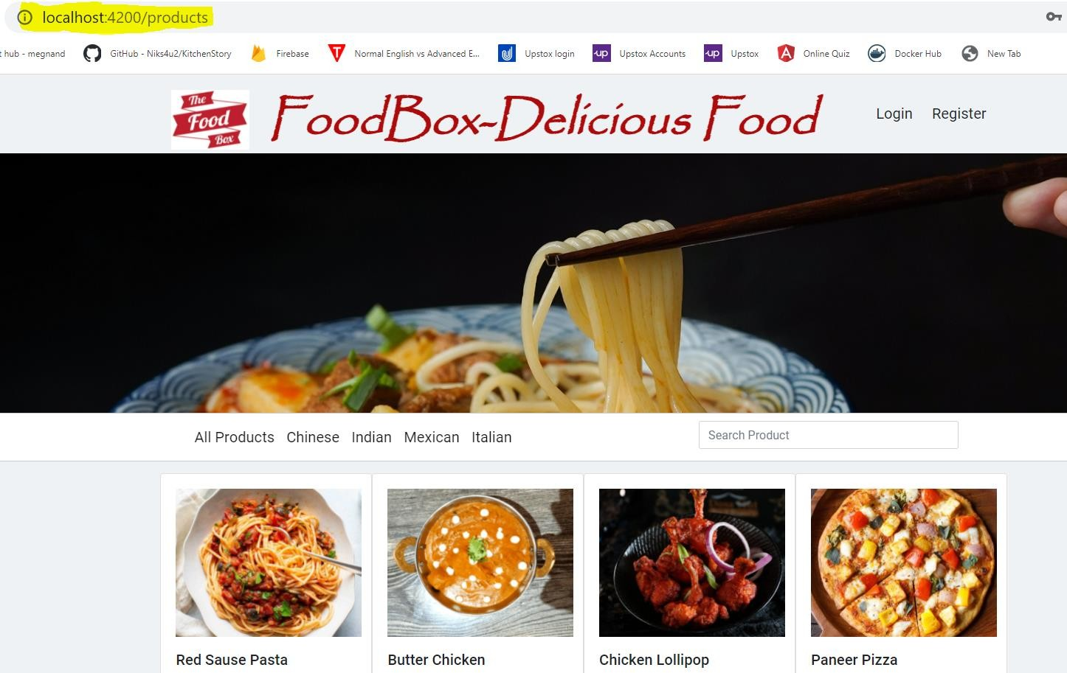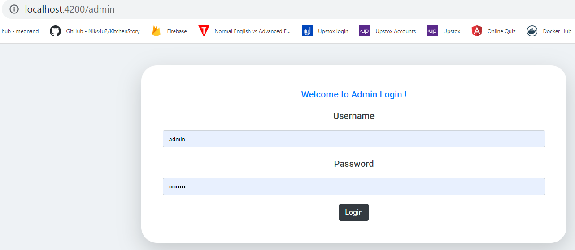

Category Based Searching

http://localhost:4200/products

15

THANK YOU……………

16